**Output (Screen shot)**

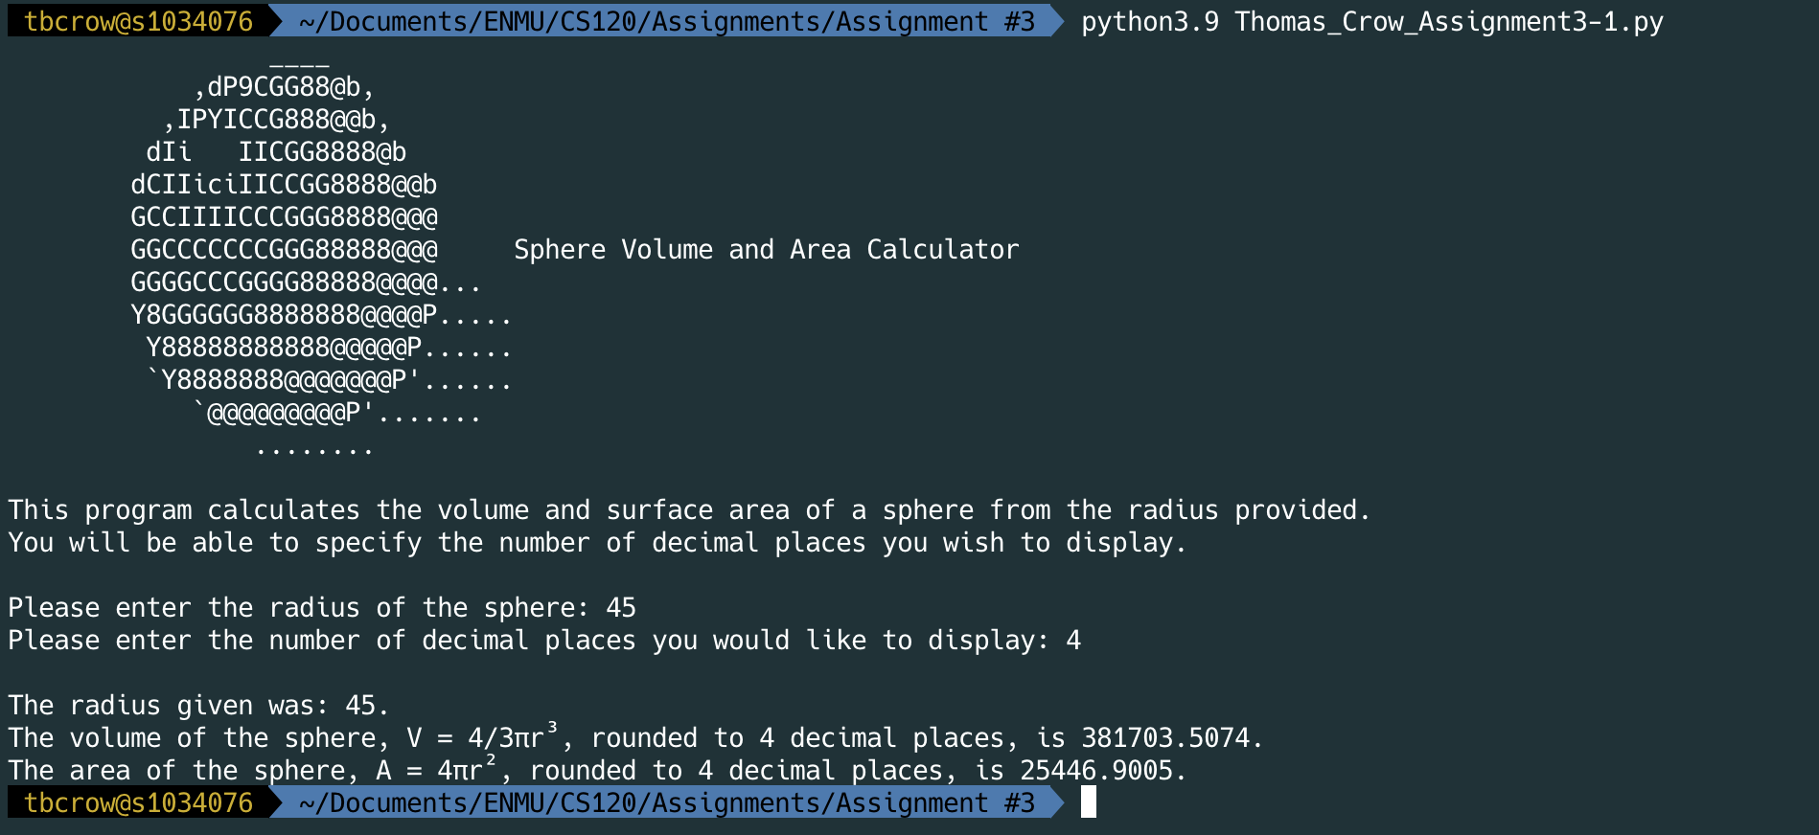

**Output (Copied and pasted)**tbcrow@s1034076  ~/Documents/ENMU/CS120/Assignments/Assignment #3  python3.9 Thomas_Crow_Assignment3-1.py  ✔  118  17:32:25

____

,dP9CGG88@b,

,IPYICCG888@@b,

dIi IICGG8888@b

dCIIiciIICCGG8888@@b

GCCIIIICCCGGG8888@@@

GGCCCCCCCGGG88888@@@ Sphere Volume and Area Calculator

GGGGCCCGGGG88888@@@@...

Y8GGGGGG8888888@@@@P.....

Y88888888888@@@@@P......

`Y8888888@@@@@@@P'......

`@@@@@@@@@P'.......

........

This program calculates the volume and surface area of a sphere from the radius provided.

You will be able to specify the number of decimal places you wish to display.

Please enter the radius of the sphere: 45

Please enter the number of decimal places you would like to display: 4

The radius given was: 45.

The volume of the sphere, V = 4/3πr³, rounded to 4 decimal places, is 381703.5074.

The area of the sphere, A = 4πr², rounded to 4 decimal places, is 25446.9005.

tbcrow@s1034076  ~/Documents/ENMU/CS120/Assignments/Assignment #3 